Home Exercise Program for Each Stage of Recovery for a Rotator Cuff Repair
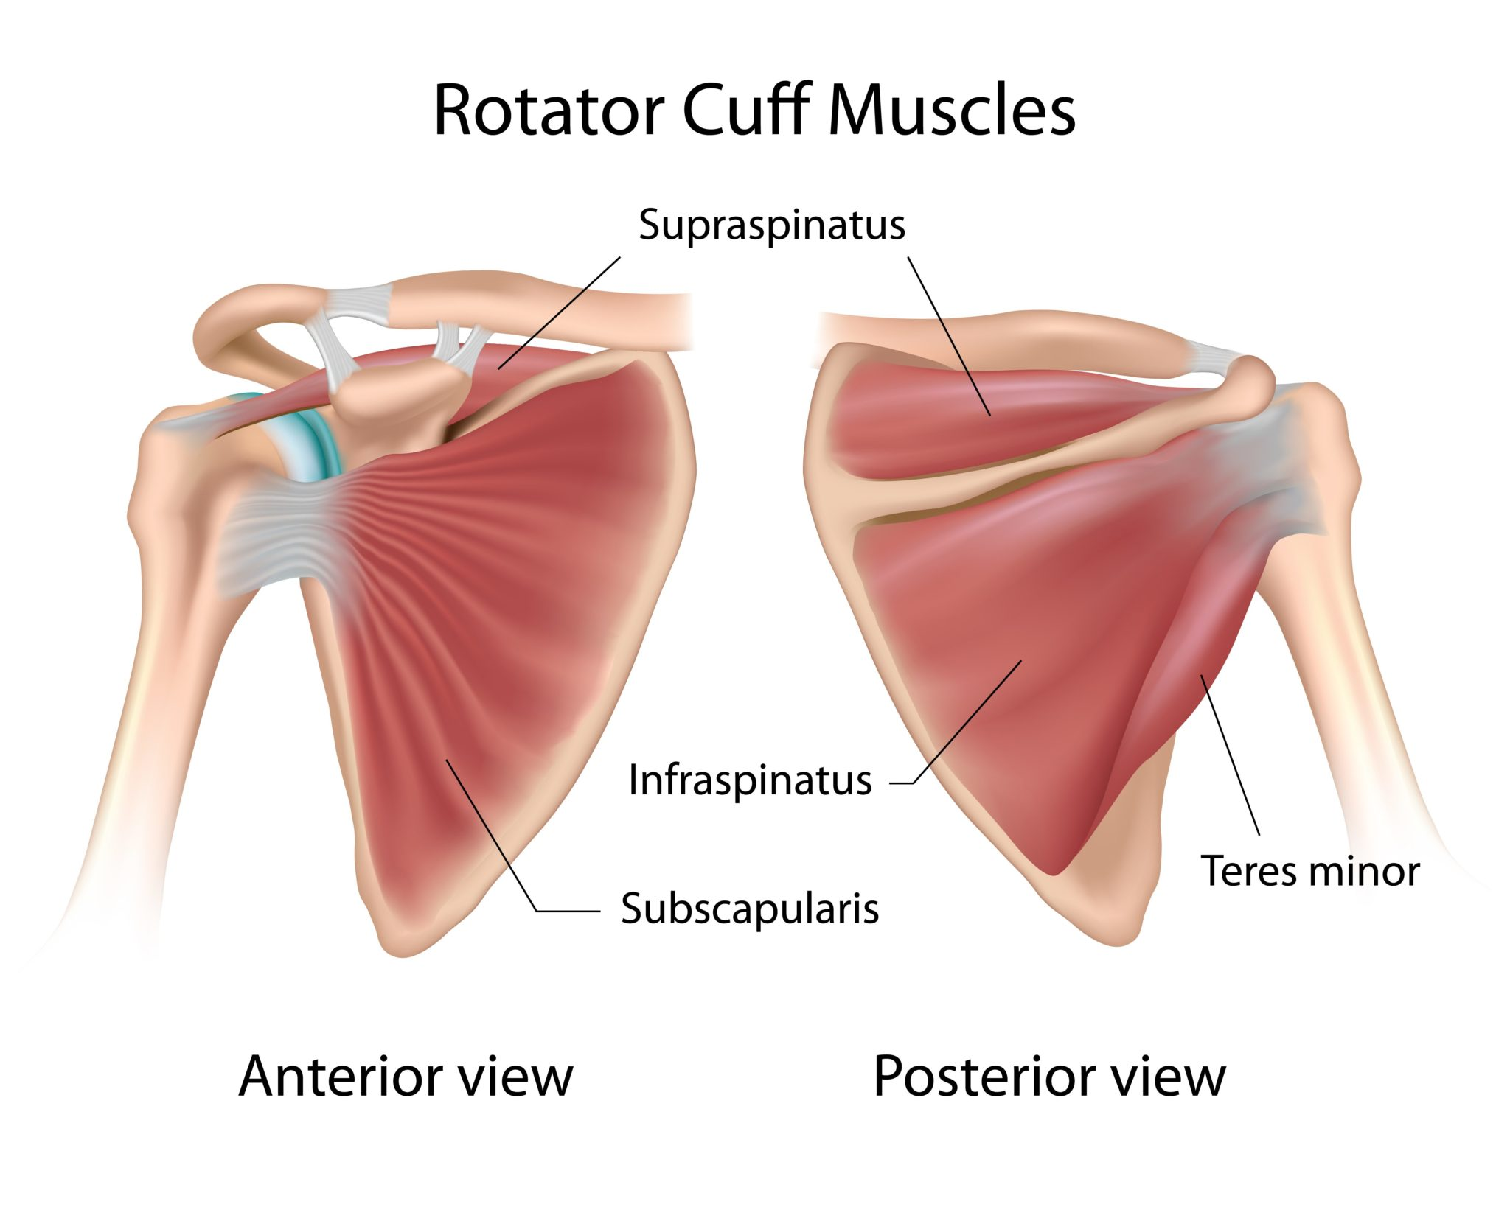

Jordan Applekamp
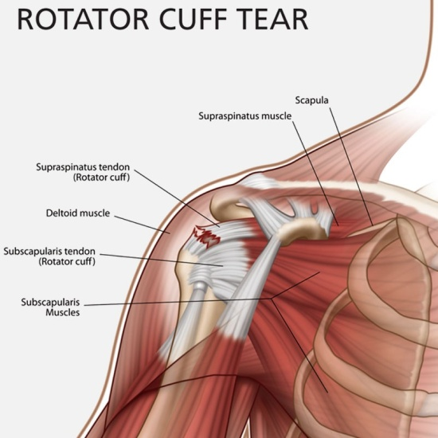
What is the Rotator Cuff?
The rotator cuff consists of four small muscles that originate on the scapula (shoulder blade) and attach with tendons around the head of the humerus (upper arm bone). These four muscles form a “cuff” that keeps the ball shaped head of the humerus seated in the shallow socket of the scapula. The tendon is the most common sit for rotator cuff tear and may involve one or more of the four tendons.

What is Rotator Cuff Repair?
In Rotator Cuff Repair surgery, the torn muscle tendon(s) are reattached back onto the humerus to improve shoulder function and reduce shoulder pain.

How is Rotator Cuff Repair surgery performed?
Metal or absorbable screws are inserted into the humerus. These screws have sutures attached to the top that are threaded through the torn portion of the rotator cuff tendon, and pulled tight to anchor the tendon down onto the humerus. This procedure is performed through an arthroscope, or through a small incision.

What can I expect after surgery?
Pain management
1. Medication: The arm receiving surgery will be numb for 6-12 hours after surgery due to receiving a nerve block. When the nerve block wears off, shoulder pain is expected. In order to minimize pain, pain medication and anti-inflammatory medication should be taken as prescribed. Staying ahead of pain with the use of the prescribed medication will make it easier to manage.

2. Ice will help bring down the inflammation, but some inflammation is good because the body is bringing blood flow to that area of the body for healing. Use ice as needed to help with pain.

3. Rest/Sleep: It is often difficult to assume a comfortable resting position after rotator cuff repair surgery. It is recommended to place a pillow behind the upper arm to keep the arm from dropping back, and to sleep sitting propped up in bed or in a recliner during the first month after surgery.

Function
1. Sling immobilization: The arm will be immobilized in a sling for 4-6 weeks from the date of surgery. It is very important that the sling be worn at all times, except for during prescribed exercises, and basic grooming. The sling should even be worn during sleep. Due to the immobilization and immediate post-operative discomfort, it is often helpful to plan to have assistance for the first several days following surgery.

2. Dressing/grooming: It is advisable to wear shirts that button up the front during the initial recovery period, and to put the operated arm into the shirt sleeve first, followed by the non-operative arm. The sling may be removed while showering, with care taken to have the arm hang passively while washing.

3. Activity Guidelines: No lifting-Only take sling off to bathe- No behind the back motions-No movements above 90 degrees.

ACUTE PHASE REHAB FOR ROTATOR CUFF REPAIR

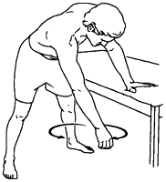
SHOUDLER PENDULUM:
- Lean over with your good arm supported on a table or chair.
- Relax the arm on the painful side, letting it hang straight down.
- Slowly begin to swing the relaxed arm by moving your body. Move it in a circle, then reverse the direction. Next, move the arm backward and forward. Finally, move it side to side.
- Let gravity gently sway your arm. Do not move it with your muscles.
- Do the exercise 3 times a day, for 5 to 10 minutes each time. Change the direction of your movement after 1 minute of motion.
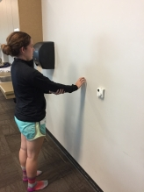
WALL CLIMBING
- Make sure that you are not bring your arm higher than 90 degrees of shoulder flexion.
- With elbow straightened (or bent if pain with straightened) slowly crawl up, down, and side to side the wall with your fingers in a flexion pattern as seen in the picture.
- This needs to be done in pain free range.
- You may use your other arm to assist the arm to help.
- Do the exercises 3 times a day, for 5 minutes going in all directions.

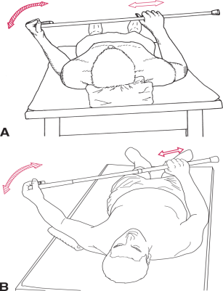
CANE EXERCISES
- Hold the cane, dowel rod, or yardstick in both hands. Keeping the upper arm of you affected
- shoulder close to your side, bend your elbows to 90 degrees. Using your unaffected hand, push your affected hand away from your side
- Do this exercise 3 times a day, with 2 sets of 10 repetitions going in and 10 repetitions going out.

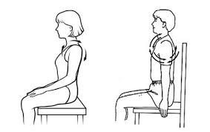

SHOULDER ROTATION

Move your shoulders in a circular pattern as shown so that you are moving in an up, back and down direction.

Perform small circles if needed for comfort.

Make sure this is done in pain free range.

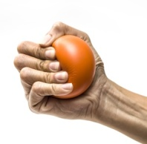
Do this exercise 3 times a day, at 30 seconds each direction.

GRIPPING

With an elastic ball, firmly squeeze it in the palm of your hand with a HOOK GRIP as shown.

Do this exercises periodically through the day.
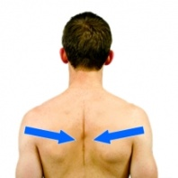

SCAPULAR RETRACTORS

Draw in your shoulder blades without hiking your shoulders. Focus on squeezing that 100 bill between those shoulder blades.

Do this exercise 3 times a day 3 sets of 10 repetitions

Reflection of Acute Phase Exercises

The reason that I chose these exercises for a patient that is in the acute phase of rehab of a rotator cuff repair was because at this time we want to promote healing and by doing these exercises, they will help all the surrounding joints stay mobile while the shoulder is healing. It is important to keep moving the surrounding joints, so when the patient starts to be able to use their shoulder again, there will be less stress on the shoulder joint, helping for a faster recovery.

For the first exercise, I chose to have the patient do the shoulder pendulum. This pendulum exercise has been proven to be very effective in this stage of healing. It is very important to let the trunk and gravity do this exercise and by allowing the trunk and gravity do all the work, it decreases the pressure in the joint capsule. This exercise will loosen up the joint, while not damaging any tissue that is trying to heal. It is also very easy and effective for the patient to do at home.

For the second exercise, I chose wall climbing with the fingers. This is an effective exercise to help gain range of motion in all directions and will keep the blood flowing that will assist in the healing process. This exercise promotes movement at the shoulder, but at the elbow and wrist joint as well. By using the unaffected arm to assist the effected arm, it is a great active assisted range of motion exercise. The patient should not go over 90 degrees in this phase, but it will still be a beneficial exercise.

For the third exercise, I wanted to focus on the unaffected arm helping the affected one. So I chose cane exercises that will help the other arm move passively and can help maintain that range of motion. By using this exercise, the unaffected arm is doing all the work and helping the affected arm with gaining range of motion.

For the fourth exercise, it is important to do shoulder rotations because it loosens up the upper neck muscles to take some pressure off of the shoulder joint. This exercise will help relax the patient and will keep that joint moving. I think sometimes we are so focused on not moving the shoulder and letting it heal, but need have time to focus on other parts of the body while the tissues are healing.

For the fifth exercise, I chose to give the patient a gripping exercise. This will help keep

the blood moving and will help to strengthen the surrounding muscles. This will help keep the surrounding joints strong while the shoulder is healing. Also, by doing these gripping exercises can help prevent blood clots from forming after surgery.

For the sixth exercise, I wanted to have the patient work on the scapula. Scapular movements are key in assisting with shoulder motions. By moving the scapula, it will help in a faster recovery time for the shoulder itself. We do not want the scapular muscles getting tight because that can and will affect the shoulder movement.

For other interventions in this phase of healing, I think it is important to focus on promoting healing and pain management so using heat or massage would be very beneficial for this patient. The patient would benefit from an upper extremity and neck massage to help bring blood to the area to promote healing and to help keep the surrounding joints from stiffening up. Some light stretching of the neck muscles could also be helpful to take some pressure off of the shoulder and can help with pain management.

For the education topics, I chose to talk about the diagnosis and explain exactly what happened from what the rotator cuff is, from what was torn, to how it was being fix and some precautions that need to be taken. It is important that they have these precautions with them at home so they know what they should not be doing because if they break these precautions, it could lead to a longer recovery, or worse tearing the rotator cuff again. I think it is important for the patient to have a better understanding of the procedure because we want the patient to understand how important this first phase is in the recovery phase for the future of their shoulder and its motion.

SUBACUTE PHASE OF HEALING
Now that we gave the shoulder some time it needed to heal, it is important for us to start light strengthening and active range of motion exercises. This phase of healing normally lasts for 6-12 weeks, but can vary for each patient. Now that some of the tissues are healed, we are moving to the repair or proliferation phase, which means that the wound begins to be rebuilt with new, healthy granulation tissue. For the granulation tissues to be formed, the blood vessels must receive a sufficient supply of nutrients and oxygen. This new tissue is made up of a mixture of extracellular matrix and collagen, which allows for the development of a new network of blood vessels to replace the damaged ones.
The tendon healing to bone is progressively increasing and able to withstand applied muscle forces generated by simply raising the arm only to 90 degrees of shoulder flexion. Movement is critical during this stage. If pain or the fear of pain prevents movement during this stage, the fibroblasts will lay down scar tissue randomly throughout the affected tissues. These fine threads of adhesion will bind the muscle fibers to one another and also bind connective tissue to muscles and joints. The

result will be painfully restricted motion. If however you put the affected joint through a full range of motion during this stage, the cross fibers of adhesion binding muscles and other tissues together will be broken, while the fibers that support the normal range of motion will become stronger. That is why it was so important in the first phase that we let those tissues settle and heal and this will increase muscle activity and help restore normal patterns of muscle contraction that will enable return to function and allow normal activities of daily living. The goal is to get the shoulder muscles firing in a pain free position and continue to stay under 90 degrees of shoulder flexion. Before the patient can move into the next stage, the goal is to get full active range of motion. So working on range of motion is critical in this stage.

Some precautions that the patient should follow such as:

No lifting

No supporting of body weight by hands and arms

No excessive behind the back movements

No sudden jerking motions

SUBACUTE PHASE FOR ROTATOR CUFF REPAIR
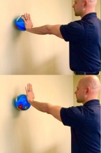
BALL ON WALL
- While standing and holding a ball on a wall, lean into the ball and roll the ball in small circles.
- Make sure to not go over 90 degrees of shoulder flexion.
- Do this exercise for 3 times a day for 30 seconds in each direction.

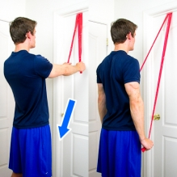
ELASTIC BAND EXTENSION BILATERAL SHOULDE RESITANCE BELOW 90
- While holding an elastic band with both arms in front of you with your elbows straight, pull the band downwards and back towards your side.
- Do this exercise 3 times a day 3 sets of 10 repetitions.

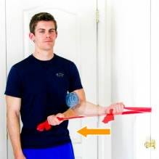
ELASTIC BAND SHOULDER INTERNAL ROTATION - IR AND ER
- While holding an elastic band at your side with your elbow bent, start with your hand away from your stomach, then pull the band towards your stomach. Keep your elbow near your side the entire time with a towel roll in between your arm.
- Do this exercise 3 times a day, 3 sets of 10 repetitions.

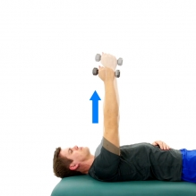
SCAPULAR PROTRACTION - FREE WEIGHT - SERRATUS PUNCHES
- Lie on your back holding a small free weight or soup can with your arm extended out in front of your body and towards the ceiling. While keeping your elbow straight, protract your shoulders forward towards the ceiling and then lower back down in a control motion. 1-2# weights. Do not exceed 2#.
- Do not allow your shoulder to raise towards your ears.
- Keep your elbow straight the entire time.
- Do this exercises 3 times a day, 3 sets of 10 repetitions.
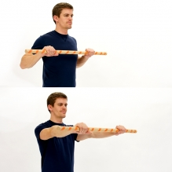
WAND PRESS - STANDING
- Start by holding a wand or cane at chest height.
- Next, slowly push the wand outwards in front of your body so that your elbows become fully straightened. Then, return to the original position.
- Do this exercise 3 times a day 3 sets of 10 repetitions.
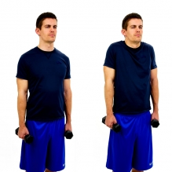
SHRUGS WITH WEIGHTS
- While holding weights, raise your shoulders upward towards your ears as shown. Shrug both shoulders at the same time.
- Do this exercise 3 times a day with 2lbs free weights, 3 sets of 10.

Reflection on Exercise for Subacute Phase
The exercises that I chose where mostly to do some light strengthening and work on active range of motion. We are using no more than 2 pounds of free weights because then we are not strengthening the right muscles in and around the shoulder.
For the first exercise I chose ball rolls on the wall. By using the ball against the wall it is helping strengthening the rotator cuff muscles and helps get more movement at the joint which will help increase the range of motion. This exercise will also help stabilize the shoulder joint. By choosing an exercise like this, it is very easy to progress to larger circles at different angles.
For the second exercise, I chose to use a yellow resistance band starting at 90 and pulling down to help strengthen the triceps. By doing light resistance exercise, it will help for when we start exercises beyond 90 degrees to help with eccentric control. Since the triceps also help stabilize the shoulder joint, strengthening of this muscle is needed.
For the third exercise, I thought it would be appropriate for the patient to work on internal and external rotation using a theraband to help strengthen those muscles. For example, if the subscapularis tendon is torn, then internal rotation would be weak, because the subscapularis does internal rotation. Another reason why these exercises are so important is because out of the four rotator cuff muscles, two of them, the teres minor and the infraspinatus perform external rotation. It proves right there why these exercises need to be done for the shoulder and are a key component of the shoulder rehab.
For the fourth exercise, I chose to have the patient do Serratus Anterior punches with 2 lbs free weights. The Serratus anterior muscle is key in shoulder movements. It is important to be able to protract and have slow and controlled retract to help with daily tasks. The Serratus Anterior helps anchor the shoulder blade against the rib cage. This gives the shoulder blade a good foundation for stability and control of the shoulder joint. It also helps rotate the shoulder blades upwards when lifting the arms overhead to help prepare for the next stage of healing when we start to go over 90 degrees.
For the fifth exercise, I chose to do wand presses that will help stabilize the scapular muscles and will help assist the shoulder when moving. By using the wand, it can also help assist the other arm. This will help strengthen the surrounding muscles around the shoulder.
For the last exercise, I chose to do shrugs with weights because having strong upper traps is important to help with strengthening the shoulder as well. Since the rotator cuff muscles have been torn and will always have some weakness, it is so important to strengthen the muscles around it to help prevent reinjury.
Some other interventions that would be appropriate in this phase would be massage to promote healing, but also I could end the treatment in ice or have the patient do ice at home because after exercise today, the patient could be sore, but I would explain that you might be a little sore because we are working those muscles that have been immobilized for awhile.
The reason that I chose the education topics that I did was I just wanted to explain what is happening on the inside as the muscles and tendons are healing. It is very important to have the patient understand how the muscles and tendons are helping, so they can be mindful in the future to prevent reinjury. The patient will be more confident moving forward with therapy knowing exactly what is happening at each phase.

CHRONIC OR REMODELING PHASE
Remodeling, also known as maturation, is the last stage of the wound healing process. It occurs after the wound has closed up and can take as long as two years. During this phase, the dermal tissues are overhauled to enhance their tensile strength and non-functional fibroblasts are replaced by functional ones. Cellular activity declines with time and the number of blood vessels in the affected area decreases and recede.
While it may appear that the wound healing process is finished when maturation begins, it’s important to keep up the treatment plan. If the wound is neglected, there’s risk of it breaking down dramatically as it is not at its optimal strength. Even after maturation, wound areas tend to remain up to 20 percent weaker than they initially were.
At this time, pain is only felt on certain movements or activities if it is felt at all. It is normal If pain occurs during the end-range of movement or during the last repetitions of a exercise routine. If pain from exercising occurs the following day, you should back off the intensity of the program.
The remodeling phase lasts at least 6 months after the injury, but can continue for years. Shoulder injuries like a torn rotator cuff can take several years to regain optimal use (which science shows is at most perhaps 80% of original function). Failure to put the joint through the full range of motion during this time can still lead to painful, contracted tissues. Stretching at this point should take the joint to the end-range, even to the point of discomfort in the joint. Pushing the limits of motion forces the joint to remodel according to your demand for full mobility.
If you engage is strength training, begin gently and progressively increase. Stressing the muscles and connective tissues stimulates growth and improved function. Failure to do so results in weakened tissues that are vulnerable to re-injury. In the beginning, strength training consists of gentle resistance exercises that can be performed on a daily basis. As you improve, you can work up to doing resistance or weight training that takes the muscle to the point of failure in 3 sets of 10 repetitions. At this intensity, a day or two of rest between sessions allows for the muscles to respond to the increased demand by growing bigger and stronger.

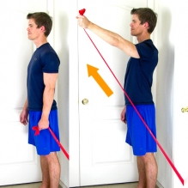
CHRONIC PHASE OF ROTATOR CUFF REPAIR

ELASTIC BAND SHOULDER FLEXION
- While holding an elastic band at your side, draw up your arm up in front of you keeping your elbow straight.
- Do this exercise 3 times a day, 2 sets of 10.

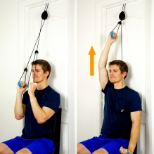
PULLEY
- Using door pulleys and facing away from the door, slowly pull down with your unaffected arm so that your affected arm raises forward and up without effort.
- Your affected arm should be relaxed. The unaffected arm does the work.
- Do this exercise 3 times a day 2 sets of 10 on each arm.

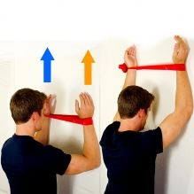
SERRATUS WALL SLIDE - ELASTIC BAND
- Place an elastic band around your arms at the level of your wrists as shown. Next, place your forearms and hands along a wall so that your elbows are bent and your arms point towards the ceiling.
- Then, protract your shoulder blades forward and then slide your arms up the wall as shown.
- Return to the original position and repeat.
- Do this exercise 3 times a day with a yellow theraband 3 sets of 10.

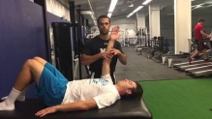
RHYTHMIC STABILIZATION FOR THE SHOUDLER
- Patient lays supine with arm at 90 degrees shoulder flexion.
- Have another person push on the arm lightly, pushing in all PNF pattern directions as patient tries to keep arm still.
- Start with resistance closer to the shoulder and to increase difficulty push more distally toward the wrist.
- Do this exercise for 3 times a day for 2 minutes each in all different directions.
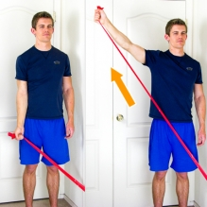
ELASTIC BAND SHOULDER ABDUCTION
- While holding an elastic band at your side, draw up your arm to the side keeping your elbow straight.
- Make sure that you are keeping your core tight and let the shoulder do the whole movement.
- Do this exercise 3 times a day, 3 sets of 10 repetitions.

Forearm Wall Lean (aka Modified Headstand)
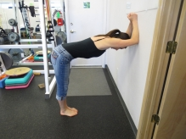
- Place your forearms on the wall, hands together. Get as close as possible to the body position shown - it is ok to bend your knees.
- Push the top of your head away from the wall, by pressing through your arms into the wall - this will cause your shoulder blades to elevate and slightly protract.
- Do this exercise 3 times a day 3 sets of 30 second holds.

Reflection on exercises for chronic phase

This is the phase were we really want to focus on strengthening and working our way past 90 degrees of flexion. SO for a lot of my exercises we are strengthening and working on stabilization of the shoulder.
For the first exercise, I chose to have the patient use an theraband, hooking it into the door at the bottom and pulling up above 90. In this phase of healing, it is so important to get the shoulder muscles strong because they have been immobilized for awhile now. This is an easy exercise to do at home and is very easy to progress. By having the patient do this exercises at home, will help prevent reinjury.
For the second exercise, I chose to have the patient do a pulley exercise. This exercises can help with range of motion and also help with strengthening both shoulders.
For the third exercise, I chose to do a Serratus wall slide. The Serratus Anterior muscle helps the shoulder a lot and is often forgotten about. Therefore, it is important to strengthen the Serratus and by using a resistance band, it adds some difficulty doing this exercise.
For the fourth exercise, I wanted the patient to be able to work on stabilizing the shoulder. Just being aware of where your shoulder joint is at in space is very important when it comes to random perturbations. This will help the patient in the future when random and unplanned perturbations happen, the right muscles will be able to fire and protect the shoulder joint.
For the fifth exercise, I chose to have the patient do another exercise with the theraband doing shoulder abductions. By using the theraband, it is apply some slight resistant for strengthening the shoulder. The first 15 degrees of shoulder abduction is with the supraspinatus and the deltoid. Strengthening these muscles will help make for a very stable shoulder joint.
For the last exercise, I chose a stretch to help the patient stay flexible after strengthening. Stretching out the latissimus dorsi muscle will help keep the shoulder more mobile.
For additional interventions, in therapy we would be working on more of plyometrics and help the patient get back to their job, by doing their job tasks and show proper ergonomics to prevent reinjury. We could work on postural exercises as well.
For my education topic for this phase, I really wanted to focus on what is happening inside the joint. How we are trying to remodel the scar tissue that is forming after the surgery. It is very important for the patient to understand what is happening so they can be confident in their rehab process. It also talks about after rehab is done to keep the shoulder strong even after therapy is done.

FUNCTIONAL 5+

LIFELONG IMPACT
WHY THE CORE IS ESSENTIAL FOR LIFE (POSTURE SCREEN)
DAILY LIFE TASKS
The core helps us sit up straight in a chair, carry our groceries, rake the lawn, walk with an upright posture, and the list goes on. Without a strong core, many daily tasks, even standing or walking with correct posture, can be a chore.

SPORTS PERFORMANCE
When we watch a high-level sprinter run at top speed, we are often mesmerized by how smooth and fluid they are. There is often very little movement whatsoever at the belly button while their limbs are propelling them forward with much force and speed. This cannot be accomplished without having a strong core to stabilize everything in the middle while the limbs are moving at a high rate of speed.

HOW THE CORE IMPACTS HEALTHCARE
“Sitting is the new smoking”
“Body maintenance to prevent injury”
“Posture”
Most poor posture issues are easily fixed and may be the result of sitting down too much.
Sitting for long periods of time can cause the muscles responsible for hip flexion to be shortened. With these muscles in that shortened position for an extended time period, they will likely develop a preference to stay shortened and affect our posture when we stand. This poor posture will alter movement and muscle recruitment, increasing the risk of pain and injury

WHY THIS CORE ASSESSMENT?
The core makes up everything from the top of the shoulders to the bottom of our pelvis. The core is essential in almost every task we do in our daily routine. If there is weakness in the core, our body will recruit many different muscles, ligaments, or tendons to help move our four extremities of our body. When this happens movement patterns break down.

REASONS YOU MAY SCORE LOW IN THE POSTURE SCREEN
- You may be lacking in core strength, which is important for overall movement stability and strength.
- This may indicate that you’re carrying too much weight, and would benefit from shedding a few pounds.
- You may have a weak transverse abdominis that is needed to give your vertebrae strength and support.
- A lack of core muscle activation, decreased muscle recruitment, neuromuscular imbalance, impaired proprioception, and delayed reflex responses. Early fatigue of these muscles could be a contributor of poor posture.
- A weak core is affecting the kinetic chain of stability.
- The lack of core strength is affecting activation patterns essential for good posture.

HEP for Nick
Corrective Exercises For Plank
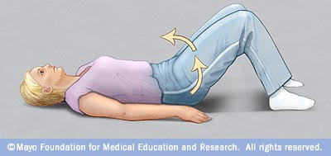
Floor Pelvic Tilts
- Lay on back with knees bent, perform anterior and posterior pelvic tilts, drawing in abs with tilt.
- Do this exercise twice a day 3 sets of 8.

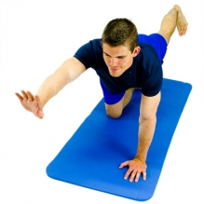
QUADRUPED ALTERNATE ARM AND LEG - BIRD DOG
- While in a crawling position, brace at your abdominals and then slowly lift a leg and opposite arm upwards.
- Maintain a level and stable pelvis and spine the entire time.
- Do this exercise twice a day 3 sets of 8

DEAD BUG
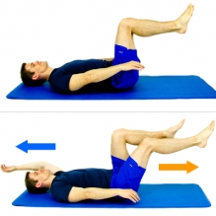
- While lying on your back with your knees and hips bent to 90 degrees, use your stomach muscles and maintain pelvic neutral position. Do not allow your spine to move.
- Hold pelvic neutral and then slowly straighten out a leg without touching the floor. At the same time raise an opposite arm over head. Do not allow your spine to arch during this movement.
- Return to starting position and then repeat on the opposite side.
- Do this exercise twice a day 3 sets of 8 repititions.

Correction Exercises for Hip Hinge
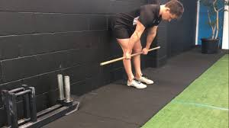
Dowel Pole Wall Walk Outs
- Standing with back against wall and holding dowel for balance, hip hinge to touch butt to wall, then walk out a step and repeat.
- Do this exercise twice a day 3 sets of 8 repetitions.

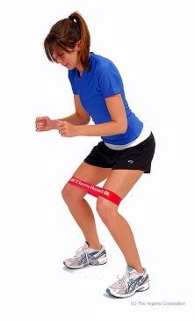
Mini Band Pinky Toe Wall Walk Outs
- Standing with back against wall, mini band around knees, hip hinge to touch butt to wall, then walk out a step and repeat. Cue to keep knees aligned pushing out no further than the pinky toe.
- Do this exercise twice a day 3 sets of 8 repetitions.
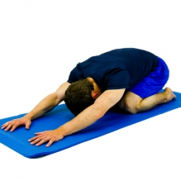

CHILD POSE - PRAYER STRETCH
- While in a crawl position, slowly lower your buttocks towards your feet until a stretch is felt along your back and or buttock.
- Do this exercise twice a day 2 sets of 30 second holds.

REFLECTION ON EXERCISE FOR NICK

For the student that I had, he had almost all ones except box skip and squat. So what I decided to focus on was plank and hip hinge. I also gave him a stretching exercise to make sure he is not just getting stronger, but also stretching.
For the first exercise, I wanted to work on plank area because he was lacking there. So I chose a corrective exercise called posterior pelvic tilts. This is really easy for him to do at home and it a great way to help him straighten out that curve and strengthen his core which will help stretch his back muscles.
For the second exercise, I chose quadruped. Activation of transverse abdominis is key in this exercise and will help with his plank. It is important that the core is activated otherwise it could be activating the wrong muscle group.
For the third exercise that I chose still working on the plank portion. The dead bug exercise is a great core exercise and has lots of ways to progress and make harder for him as he gets stronger. If I had more time with this student, I would explain to the student how to activate the transverse abdominis muscle because that muscle is key in core exercises. By having a strong core, that will help with mostly every movement in the body.
For the next set of exercises, I wanted to focus in on the hip hinge and give him exercises directly related helping correct the hip hinge. First I decided to give him dowel pole wall walk outs. This exercises is a correction exercises specifically for the hip hinge.
The next exercise as a correction for the hip hinge is using a mini band around the knees with pinky tow wall walk outs. This will help him do this mini squat against the wall. This exercise is specifically designed to work on the hip hinge. This exercise will help the child be stronger in his squats and be able to keep his legs aligned.

For the last exercise, I just wanted to give him an easy, but yet effective stretching exercise. I chose to have him do the child pose because it will help stretch out the latissimus dorsi and help his muscles relax after doing all of those other exercises.
For the education topic that I gave him, I thought it was interesting and important to understand why core is so important in every daily task. The child might wonder they the functional 5 is so important, so I chose one aspect that I thought was very important and it explained why core is important in everyday life. It is a great education topic to give to the child.

REFERENCES

Li, X., Vo, A., Zhou, H., & Dumont, G. (2013, May 15). Physical Therapy and Rehabilitation after Rotator Cuff Repair: A Review of Current Concepts. Retrieved from https://www.omicsonline.org/physical-therapy-and-rehabilitation-after-rotator-cuff-repai-a-review-of-current-concepts-2329-9096.1000142.php?aid=16026
McDowell, C. F., Clark-McDowell, T., & Cortesia Sanctuary. (n.d.). The 3 PHASES OF HEALING. Retrieved from http://www.solomonsseal.net/3PhasesHealing.html
Yong, T. (2018, October 17). The Forgotten Muscle of the Shoulder: Serratus Anterior. Retrieved from https://innovationphysio.com/blog/forgotten-muscle-shoulder-serratus-anterior/

